PART A
(Part A: TO BE REFFERED BY STUDENTS)
Experiment No. 05
A.1 AIM:
Apply styling to Webpages using Inline, Internal and External CSS.
A.2 Pre requisite:
Basic Knowledge of HTML, JavaScript and CSS
A.3 Outcome:
After successful completion of this experiment students will be able to:
- Create formatted web pages/websites with attractive look and feel
- Use both internal and inline style sheets of CSS
A.4 Theory:

What is CSS?
CSS stands for Cascading Style Sheets. Styles define how to display HTML elements. Styles were added to HTML 4.0 to solve a problem. External Style Sheets can save a lot of work. External Style Sheets are stored in CSS files. CSS defines HOW HTML elements are to be displayed. Styles are normally saved in external .css files. External style sheets enable you to change the appearance and layout of all the pages in a Web site, just by editing one single file!

CSS Syntax
A CSS rule set consists of a selector and a declaration block:
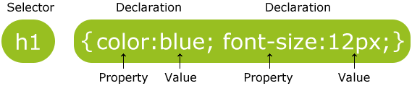
The selector points to the HTML element you want to style.
The declaration block contains one or more declarations separated by semicolons.
Each declaration includes a property name and a value, separated by a colon.
Properties | Values
background-attachment | scroll, fixed
background-color | (color), transparent
background-image | none, (location)
background-position | (percent), (length), top, center, bottom, left, center, right
background-repeat | repeat, repeat-x, repeat-y, no-repeat
Background | Any of the above background values separated by spaces.
Color | (color)

Properties | Values
margin-bottom | (length), (percent), auto
margin-left | (length), (percent), auto
margin-right | (length), (percent), auto
margin-top | (length), (percent), auto
margin | Any of the above margin values in top, right, bottom, left order separated by spaces.
padding-bottom | (length), (percent)
padding-left | (length), (percent)
padding-right | (length), (percent)
padding-top | (length), (percent)
padding | Any of the above padding values in top, right, bottom, left order separated by spaces.
border-bottom-width | medium, thin, thick, (length)
border-bottom | Any of the border-top-bottom, border-color and border-style values.
border-color | (color)
border-left-width | medium, thin, thick, (length)
border-left | Any of the border-top-left, border-color and border-style values.
border-right-width | medium, thin, thick, (length)
border-right | Any of the border-right-width, border-color and border-style values.
border-style | none, dotted, dashed, solid, double, groove, ridge, inset, outset
border-top-width | medium, thin, thick, (length)
border-top | Any of the border-top-width, border-color and border-style values.
border | Any of the border values. Applies to all borders.
height | auto, (length), (percent)
width | auto, (length), (percent)
list-style-type | disc, circle, square, decimal, lower-roman, upper-roman, lower-alpha, upper-alpha, upper-latin, hebrew, armenian, georgian, cjk-ideographic, hiragana, katakana, hiragana-iroha, katakana-iroh, none
list-style-image | none, (url)
list-style-position | outside, inside
Properties | Values
list-style | Any of the above list-style values separated by spaces.
white-space | normal, pre, nowrap
border-collapse | collapse, separate, inherit
border-spacing | (length)(length), inherit
caption-side | top, bottom, left, right, inherit
empty-cells | show, hide, inherit
speak-header | once, always, inherit
table-layout | auto, fixed, inherit

Three Ways to Insert CSS
There are three ways of inserting a style sheet:
- Internal style sheet
- Inline style
- External style sheet

Internal Style Sheet
An internal style sheet should be used when a single document has a unique style. You define internal styles in the head section of an HTML page, inside the <style> tag, like this:
<head>
<style>
hr {color: sienna;}
p {margin-left: 20px;}
body {background-image: url("images/background.gif");}
</style>
</head>

Inline Styles
An inline style loses many of the advantages of a style sheet (by mixing content with presentation). Use this method sparingly!
To use inline styles, add the style attribute to the relevant tag. The style attribute can contain any CSS property. The example shows how to change the color and the left margin of a paragraph:
<p style="color:sienna;margin-left:20px;">This is a paragraph.</p>

A.5 Procedure/Task:
1. Format the web page designed by you in second experiment using CSS style sheets (use both internal and inline style sheets)
2. Use all properties of CSS discussed in class (list properties, font properties, color and background properties, text properties etc.)
3. Create an HTML page with following specifications –
- Insert 3 images. Use inline CSS to set different widths and border styles for each image. When mouse pointer hovers on the images the size of the images should become larger and semi transparent. The images should have rounded borders.
- Create an <h1> heading, two paragraphs, and a list. Use internal CSS to
- Make the heading red and center-aligned.
- Set paragraph text to gray with higher line spacing.
- Change list items bullet style to square.

- Create a table with 4 rows and 3 columns. Use external CSS to:
- Add borders around the table and cells.
- Alternate row background colors.
- Then, use inline CSS on one specific cell to make its background yellow.
• Create a horizontal navigation menu. Add hover effects. Highlight the active link
4. Design a user profile card as shown below using HTML and External CSS. The profile card should include:
- A profile image at the top
- The name of the person
- A short description or bio
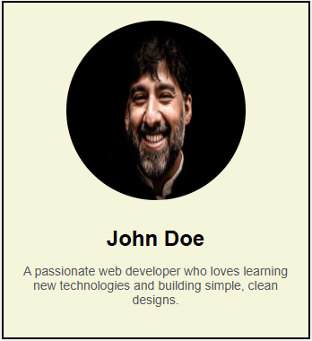
5. Prepare the document. Save and close the file and name it as EXP05_Roll no_Batch no.

PART B
(PART B: TO BE COMPLETED BY STUDENTS)
(Students must submit the soft copy as per following segments within two hours of the practical. The soft copy must be uploaded on the Blackboard or emailed to the concerned lab in charge faculties at the end of the practical in case the there is no Black board access available)
Roll No. : C-147 | Name: Saumya Sura
Class :D | Batch :D1
Date of Experiment : | Date/Time of Submission :
Grade :
B.1 Code:
1) <!DOCTYPE html>
<html lang="en">
<head>
<meta charset="utf-8">
<title>Dog Breeds Hub - Explore Popular Breeds</title>
<meta name="viewport" content="width=device-width, initial-scale=1.0">
<link href="https://fonts.googleapis.com/css2?family=Montserrat:wght@600;700&family=Roboto:wght@400;500&display=swap" rel="stylesheet">
<style>
body {
margin: 0;
background: linear-gradient(120deg, #f7f1e3 0%, #e0eafc 100%);
font-family: 'Roboto', Arial, sans-serif;
color: #222;
min-height: 100vh;
}
.hero {
background: linear-gradient(90deg, #ff9f43 60%, #0abde3 100%);
color: #fff;
padding: 36px 0 18px 0;
text-align: center;
box-shadow: 0 4px 24px rgba(255,159,67,0.10);
position: relative;
overflow: hidden;
}
.hero-title {
font-family: 'Montserrat', Arial, sans-serif;
font-size: 3.2em;
font-weight: 700;
letter-spacing: 2px;
margin-bottom: 8px;
text-shadow: 2px 2px 12px #ffb36644;
animation: slideIn 1.2s cubic-bezier(.68,-0.55,.27,1.55);
}
@keyframes slideIn {
0% { transform: translateX(-100vw); opacity: 0; }
100% { transform: translateX(0); opacity: 1; }
}
.hero-desc {
font-size: 1.3em;
font-style: italic;
opacity: 0.95;
margin-bottom: 0;
}
.container {
display: flex;
flex-wrap: wrap;
gap: 32px;
max-width: 1200px;
margin: 36px auto 0 auto;
padding: 0 18px;
}
.sidebar {
flex: 1 1 260px;
max-width: 320px;
min-width: 220px;
background: #fff;
border-radius: 18px;
box-shadow: 0 2px 16px #ff9f4333;
padding: 28px 18px 18px 18px;
margin-bottom: 24px;
align-self: flex-start;
}
.sidebar h2, .sidebar h3 {
font-family: 'Montserrat', Arial, sans-serif;
color: #ff9f43;
margin-top: 0;
margin-bottom: 8px;
font-size: 1.5em;
}
.sidebar h3 {
color: #0abde3;
font-size: 1.15em;
margin-top: 24px;
}
.sidebar ul {
list-style: none;
padding: 0;
margin: 0 0 0 8px;
}
.sidebar ul li {
margin: 12px 0;
font-size: 1.08em;
font-weight: 500;
letter-spacing: 0.5px;
}
.sidebar ul li a {
color: #ff9f43;
text-decoration: none;
transition: color 0.2s;
}
.sidebar ul li a:hover {
color: #0abde3;
text-decoration: underline;
}
.fun-facts {
background: linear-gradient(90deg, #0abde3 60%, #ff9f43 100%);
border-radius: 12px;
padding: 18px 14px 10px 14px;
margin-top: 24px;
box-shadow: 0 2px 12px #0abde344;
}
.fun-facts h3 {
color: #fff;
margin-bottom: 10px;
}
.fun-facts ul li {
color: #fff;
font-size: 1em;
margin: 8px 0;
font-weight: 400;
}
.main-content {
flex: 3 1 600px;
min-width: 320px;
background: #fff;
border-radius: 18px;
box-shadow: 0 2px 16px #0abde333;
padding: 32px 28px 24px 28px;
margin-bottom: 24px;
}
.main-content h2 {
font-family: 'Montserrat', Arial, sans-serif;
color: #ff9f43;
font-size: 2em;
margin-top: 0;
margin-bottom: 12px;
letter-spacing: 1px;
}
.gallery {
display: flex;
flex-wrap: wrap;
gap: 24px;
justify-content: center;
margin-bottom: 32px;
}
.breed-card {
background: linear-gradient(120deg, #f7f1e3 60%, #e0eafc 100%);
border-radius: 16px;
box-shadow: 0 2px 12px #2222;
padding: 18px 12px 10px 12px;
width: 220px;
text-align: center;
transition: transform 0.2s, box-shadow 0.2s;
border: 2.5px solid #ff9f43;
}
.breed-card:hover {
transform: translateY(-8px) scale(1.04);
box-shadow: 0 8px 32px #ff9f4344;
border-color: #0abde3;
}
.breed-card img {
width: 180px;
height: 130px;
object-fit: cover;
border-radius: 12px;
margin-bottom: 10px;
box-shadow: 0 2px 8px #0abde344;
border: 2px solid #fff;
}
.breed-card-title {
font-family: 'Montserrat', Arial, sans-serif;
color: #2c3e50;
font-size: 1.15em;
font-weight: 700;
margin-bottom: 0;
}
.care-essentials {
background: linear-gradient(90deg, #ff9f43 60%, #0abde3 100%);
border-radius: 14px;
box-shadow: 0 2px 12px #ff9f4344;
padding: 24px 18px 10px 18px;
margin-top: 18px;
}
.care-essentials h3 {
color: #2c3e50;
font-size: 1.3em;
margin-top: 0;
margin-bottom: 12px;
font-family: 'Montserrat', Arial, sans-serif;
}
.care-table {
display: flex;
flex-wrap: wrap;
gap: 18px;
justify-content: space-between;
margin-top: 10px;
}
.care-item {
flex: 1 1 180px;
min-width: 140px;
background: #fff;
border-radius: 10px;
box-shadow: 0 1px 6px #2221;
padding: 18px 8px 10px 8px;
text-align: center;
margin-bottom: 10px;
border: 2px solid #ff9f43;
transition: border-color 0.2s;
}
.care-item:nth-child(even) {
border-color: #0abde3;
}
.care-item b {
color: #ff9f43;
font-size: 1.1em;
font-family: 'Montserrat', Arial, sans-serif;
}
.care-item small {
color: #2c3e50;
font-size: 0.98em;
display: block;
margin-top: 4px;
}
@media (max-width: 900px) {
.container { flex-direction: column; gap: 0; }
.sidebar, .main-content { max-width: 100%; }
.gallery { flex-direction: column; gap: 18px; }
.care-table { flex-direction: column; gap: 10px; }
}
</style>
</head>
<body>
<div class="hero">
<div class="hero-title">🐶 DOG BREEDS EXPLORER 🐾</div>
<div class="hero-desc">Discover Amazing Dog Breeds Around the World</div>
</div>
<div class="container">
<aside class="sidebar">
<h2>🔗 NAVIGATE</h2>
<hr>
<ul>
<li><a href="index_new.html" target="_blank">➤ HOME</a></li>
<li><a href="labrador_new.html" target="_blank" style="color:#0abde3;">➤ LABRADOR</a></li>
<li><a href="beagle_new.html" target="_blank">➤ BEAGLE</a></li>
<li><a href="bulldog_new.html" target="_blank" style="color:#0abde3;">➤ BULLDOG</a></li>
<li><a href="https://www.akc.org" target="_blank">➤ AKC OFFICIAL</a></li>
</ul>
<div class="fun-facts">
<h3>⭐ FUN FACTS</h3>
<ul>
<li>✓ Dogs hear 4x better than humans.</li>
<li>✓ Each dog has unique nose print.</li>
<li>✓ Dogs can learn 250+ words.</li>
<li>✓ Puppies have 28 teeth, adults 42.</li>
</ul>
</div>
</aside>
<main class="main-content">
<h2>🖼️ FEATURED BREEDS</h2>
<div class="gallery">
<div class="breed-card" style="background: linear-gradient(120deg, #0f3460 60%, #e0eafc 100%);">
<a href="labrador_new.html" target="_blank">
<img src="https://placedog.net/280/200?id=1" alt="Labrador">
<div class="breed-card-title">LABRADOR RETRIEVER</div>
</a>
</div>
<div class="breed-card">
<a href="beagle_new.html" target="_blank">
<img src="https://placedog.net/280/200?id=2" alt="Beagle">
<div class="breed-card-title">BEAGLE</div>
</a>
</div>
<div class="breed-card">
<a href="bulldog_new.html" target="_blank">
<img src="https://placedog.net/280/200?id=3" alt="Bulldog">
<div class="breed-card-title">BULLDOG</div>
</a>
</div>
<div class="breed-card">
<img src="https://placedog.net/280/200?id=4" alt="Golden">
<div class="breed-card-title">MIXED BREEDS</div>
</div>
</div>
<div class="care-essentials">
<h3>📋 CARE ESSENTIALS</h3>
<div class="care-table">
<div class="care-item"><b>🏃 EXERCISE</b><small>Daily walks & play</small></div>
<div class="care-item"><b>🎓 TRAINING</b><small>Positive methods</small></div>
<div class="care-item"><b>🏥 HEALTH</b><small>Annual checkups</small></div>
<div class="care-item"><b>❤️ LOVE</b><small>Spend quality time</small></div>
</div>
</div>
</main>
</div>
</body>
</html>
2.
<!DOCTYPE html>
<html>
<head>
<title>Space Exploration</title>
<style>
body {
margin: 0;
font-family: "Trebuchet MS", Arial, sans-serif;
background-color: #f3f0ff;
}
header {
background-color: #1a237e;
padding: 18px 0 12px 0;
box-shadow: 0 2px 8px rgba(26,35,126,0.08);
}
nav {
display: flex;
justify-content: center;
gap: 48px;
}
nav a {
color: #e3f2fd;
text-decoration: none;
font-size: 20px;
font-weight: bold;
letter-spacing: 1px;
transition: color 0.2s;
}
nav a:hover {
color: #90caf9;
text-decoration: underline;
cursor: pointer;
}
.hero {
background-image: linear-gradient(to right, #3949ab, #90caf9);
color: #fff;
text-align: center;
padding: 48px 20px 36px 20px;
border-radius: 0 0 24px 24px;
box-shadow: 0 4px 24px rgba(57,73,171,0.10);
}
.hero h1 {
font-size: 44px;
text-transform: uppercase;
text-shadow: 2px 2px 8px #1a237e;
margin-bottom: 10px;
}
.hero p {
font-size: 22px;
word-spacing: 4px;
margin-top: 0;
}
.cards {
display: grid;
grid-template-columns: repeat(auto-fit, minmax(270px, 1fr));
gap: 28px;
padding: 40px 32px 10px 32px;
max-width: 1100px;
margin: 0 auto;
}
.card {
background-color: #fff;
border: 2.5px solid #90caf9;
border-radius: 18px;
padding: 28px 22px 20px 22px;
text-align: justify;
box-shadow: 0 2px 12px rgba(144,202,249,0.07);
}
.card h2 {
color: #3949ab;
text-decoration: underline;
margin-top: 0;
margin-bottom: 12px;
}
.card p {
font-size: 16px;
line-height: 1.7;
text-indent: 24px;
margin: 0 0 8px 0;
}
.highlight {
color: #ffb300;
font-weight: bold;
text-decoration: underline;
}
.card ul {
list-style-type: disc;
padding-left: 24px;
margin: 0;
}
.card ul li {
margin: 8px 0;
font-size: 15px;
}
.gallery {
text-align: center;
padding: 24px 0 32px 0;
}
.gallery img {
width: 240px;
height: 150px;
margin: 12px;
border: 3px solid #90caf9;
padding: 6px;
background-color: #e3f2fd;
border-radius: 10px;
box-shadow: 0 2px 8px rgba(144,202,249,0.10);
}
footer {
background-color: #1a237e;
color: #fff;
text-align: center;
padding: 12px 0;
font-size: 15px;
border-radius: 0 0 12px 12px;
margin-top: 24px;
}
</style>
</head>
<body>
<header>
<nav>
<a href="#">Home</a>
<a href="#">Missions</a>
<a href="#">Discoveries</a>
<a href="#">Gallery</a>
</nav>
</header>
<div class="hero">
<h1>Space Exploration</h1>
<p>Journey beyond our world</p>
</div>
<div class="cards">
<div class="card">
<h2>Introduction</h2>
<p>
Space exploration is the ongoing discovery and study of celestial structures in outer space by means of continuously evolving space technology.
</p>
</div>
<div class="card">
<h2>Famous Missions</h2>
<p>
<span class="highlight">Apollo 11</span> landed the first humans on the Moon.<br>
<span class="highlight">Voyager 1</span> is the farthest human-made object from Earth.<br>
<span class="highlight">Mars Rover Perseverance</span> explores the surface of Mars.
</p>
</div>
<div class="card">
<h2>Recent Discoveries</h2>
<ul>
<li>Water on Mars</li>
<li>Black hole imaging</li>
<li>Exoplanet detection</li>
<li>Organic molecules on comets</li>
</ul>
</div>
</div>
<div class="gallery">
<img src="https://images.unsplash.com/photo-1462331940025-496dfbfc7564?auto=format&fit=crop&w=400&q=80" alt="Space Shuttle">
<img src="https://images.unsplash.com/photo-1447433819943-74a20887a81e?auto=format&fit=crop&w=400&q=80" alt="Astronaut">
<img src="https://images.unsplash.com/photo-1465101046530-73398c7f28ca?auto=format&fit=crop&w=400&q=80" alt="Mars Surface">
</div>
</body>
<footer>
2026 Space Exploration. All rights reserved.
</footer>
</html>
3.
<!DOCTYPE html>
<html>
<head>
<title>Travel Destinations Showcase</title>

<link rel="stylesheet" href="style.css">
<style>
h1 {
color: red;
text-align: center;
}
p {
color: gray;
line-height: 1.8;
}
ul {
list-style-type: square;
}
nav {
background-color: #333;
text-align: center;
padding: 10px;
}
nav a {
color: white;
text-decoration: none;
padding: 10px 20px;
display: inline-block;
font-weight: bold;
}
nav a:hover {
background-color: #555;
}
nav a.active {
background-color: orange;
color: black;
}
/* External CSS for table and images */
table {
border-collapse: collapse;
width: 70%;
margin: 24px auto;
}
table, th, td {
border: 2px solid #222;
}
th, td {
padding: 12px;
text-align: center;
font-size: 16px;
}
tr:nth-child(even) {
background-color: #f3f4f6;
}
tr:nth-child(odd) {
background-color: #fff;
}
.gallery-row {
display: flex;
justify-content: center;
align-items: center;
gap: 18px;
margin-bottom: 20px;
}
.img {
transition: 0.3s;
margin: 12px;
border-radius: 30px;
display: inline-block;
}
.img:hover {
transform: scale(1.18);
opacity: 0.5;
}
</style>
</head>

<body>

<nav>
<a href="#" class="active">Home</a>
<a href="#">Destinations</a>
<a href="#">Gallery</a>
<a href="#">Contact</a>
</nav>

<h1>Top Travel Destinations</h1>

<p>
Cascading Style Sheets are used to style and layout web pages.
They allow separation of content and presentation.
</p>

<p>
CSS provides multiple ways to apply styles such as inline,
internal, and external style sheets.
</p>

<ul>
<li>Inline CSS</li>
<li>Internal CSS</li>
<li>External CSS</li>
</ul>

<h2>Destination Gallery</h2>
<div class="gallery-row">
<img src="https://images.unsplash.com/photo-1506744038136-46273834b3fb?auto=format&fit=crop&w=400&q=80"
style="width:210px; border:5px solid #e11d48; border-radius:30px;"
class="img" alt="Santorini, Greece">
<img src="https://images.unsplash.com/photo-1465101046530-73398c7f28ca?auto=format&fit=crop&w=400&q=80"
style="width:260px; border:5px dashed #2563eb; border-radius:40px;"
class="img" alt="Kyoto, Japan">
<img src="https://images.unsplash.com/photo-1462331940025-496dfbfc7564?auto=format&fit=crop&w=400&q=80"
style="width:190px; border:5px dotted #059669; border-radius:50px;"
class="img" alt="Banff, Canada">
</div>

<h2>Popular Destinations Table</h2>
<table>
<tr>
<th>Rank</th>
<th>Destination</th>
<th>Country</th>
<th>Best Season</th>
</tr>
<tr>
<td>1</td>
<td style="background-color: #ffe066;">Santorini</td>
<td>Greece</td>
<td>May - September</td>
</tr>
<tr>
<td>2</td>
<td>Kyoto</td>
<td>Japan</td>
<td>March - May</td>
</tr>
<tr>
<td>3</td>
<td>Banff</td>
<td>Canada</td>
<td>June - August</td>
</tr>
<tr>
<td>4</td>
<td>Rome</td>
<td>Italy</td>
<td>April - June</td>
</tr>
</table>

</body>
</html>
4.

<!DOCTYPE html>
<html lang="en">
<head>
<meta charset="UTF-8">
<title>Profile Card</title>
<style>
body {
background: #f8f8e7;
font-family: Arial, sans-serif;
}
.profile-card {
width: 420px;
margin: 48px auto;
background: #fafae3;
border: 3px solid #222;
border-radius: 12px;
text-align: center;
padding: 40px 32px 32px 32px;
box-shadow: 0 6px 24px rgba(0,0,0,0.10);
}
.profile-card img {
width: 220px;
height: 220px;
object-fit: cover;
border-radius: 50%;
border: 6px solid #222;
margin-bottom: 24px;
background: #111;
display: block;
margin-left: auto;
margin-right: auto;
}
.profile-card h2 {
margin: 0 0 16px 0;
font-size: 2.4em;
font-weight: bold;
color: #222;
letter-spacing: 0.5px;
}
.profile-card p {
color: #444;
font-size: 1.18em;
margin: 0;
line-height: 1.6;
padding: 0 8px;
}
</style>
</head>
<body>
<div class="profile-card">
<img src="https://randomuser.me/api/portraits/men/85.jpg" alt="Profile Photo">
<h2>Daniel Kim</h2>
<p>
Avid traveler and tech enthusiast. Loves capturing moments, coding creative projects, and sharing stories from around the world.
</p>
</div>
</body>
</html>

B.2 Output

1.
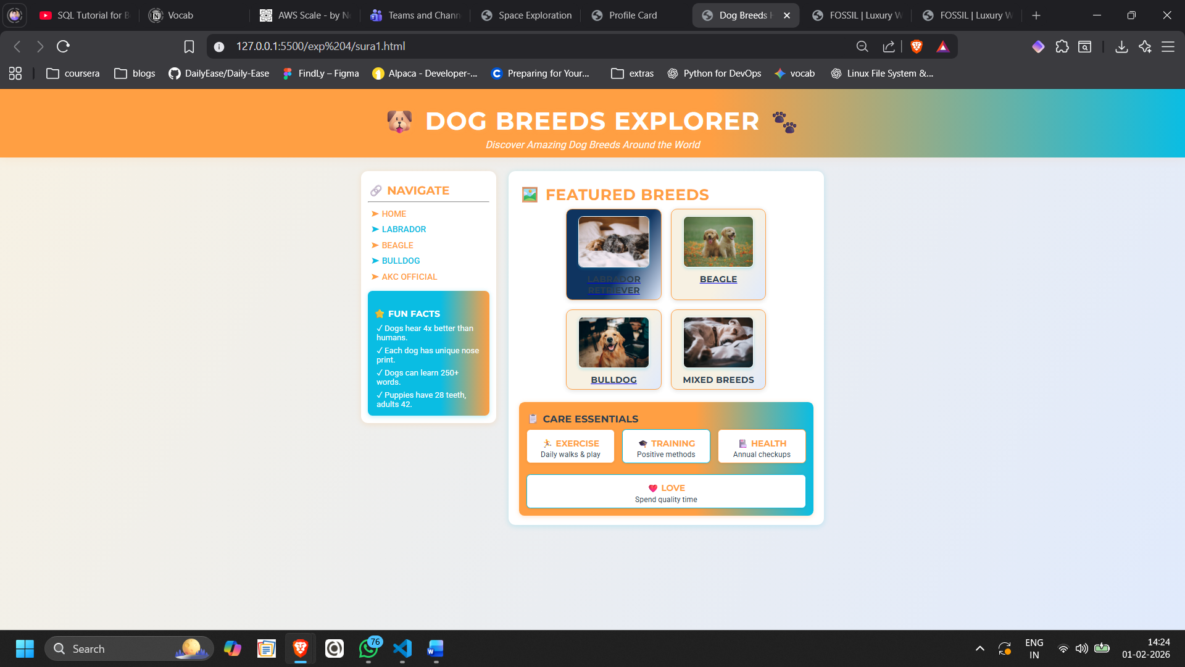
2.

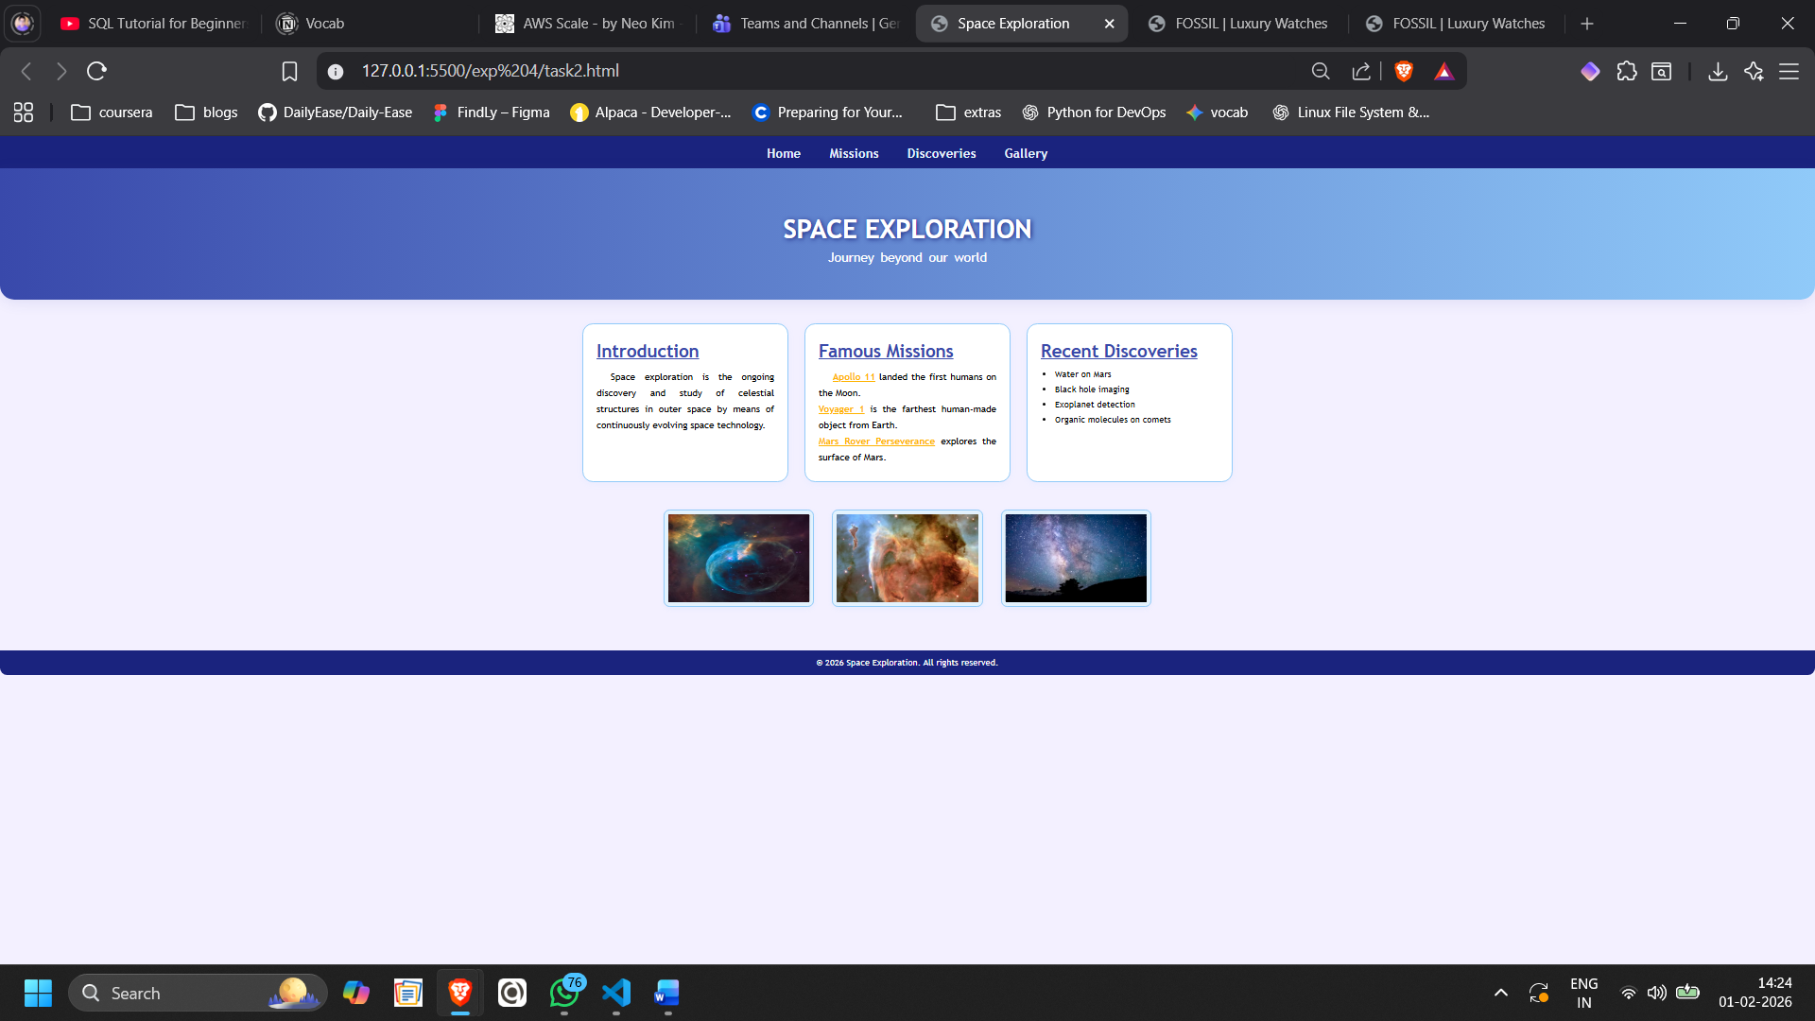
3.
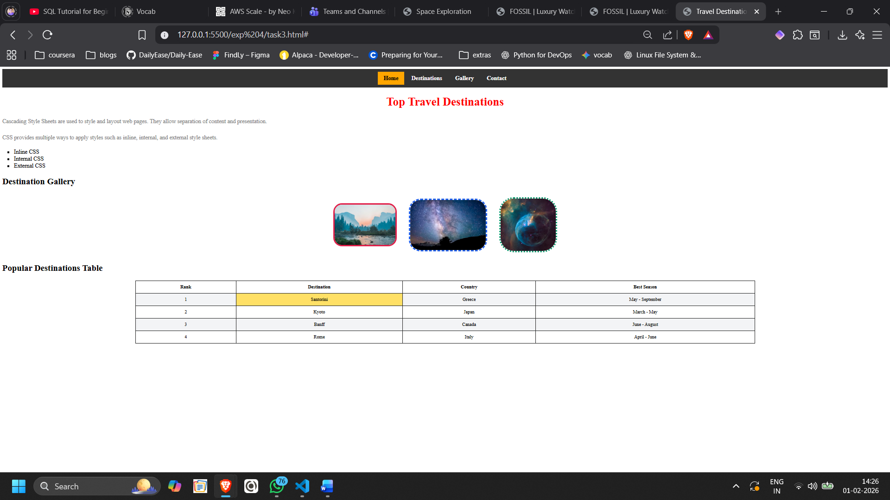

4.
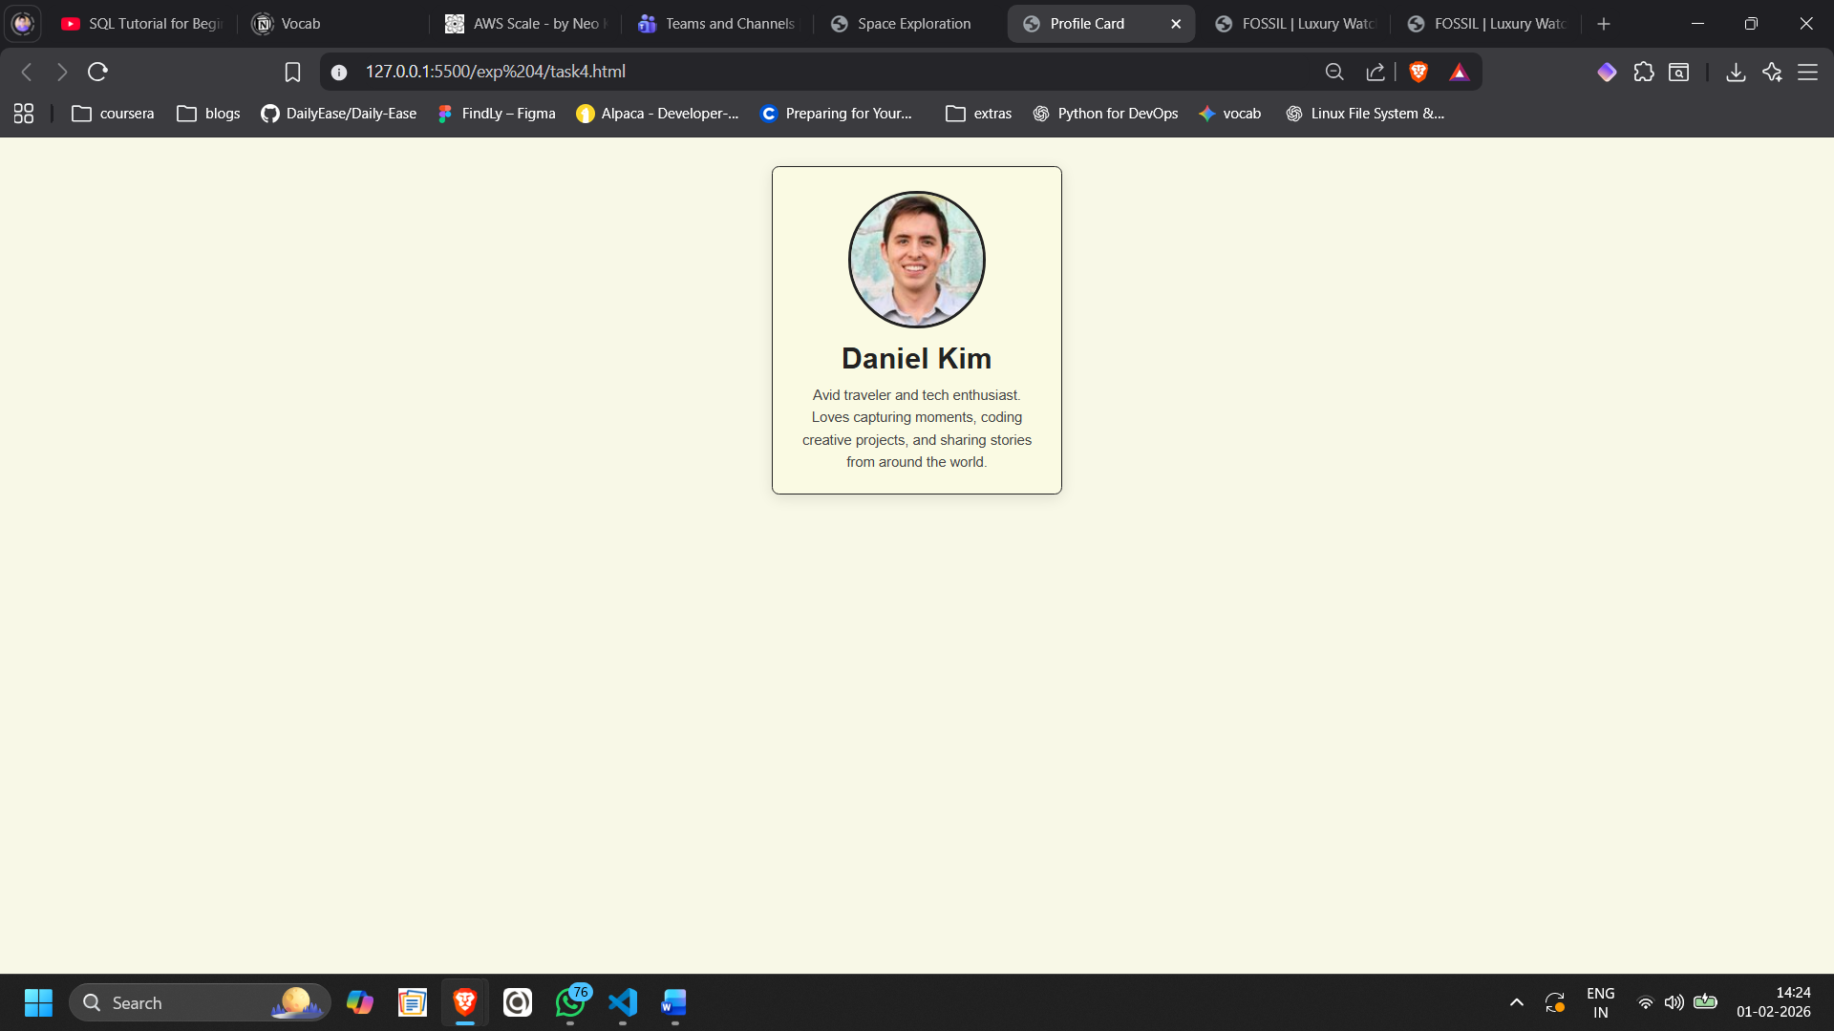

B.3 Conclusion:
From this practical, I successfully learned how to design and style web pages using Cascading Style Sheets (CSS). The practical helped me understand how CSS improves the appearance, readability, and structure of HTML elements.
B.3 Observations and Learning:
During this practical, I observed that CSS plays a crucial role in separating content from presentation in web development. I learned how different selectors like element, class, and ID selectors help in applying styles efficiently.
B.4 Question of Curiosity
(To be answered by student based on the practical performed and learning/observations)
Q1. What is CSS Style Rule? Explain with syntax.
A CSS style rule is a combination of a selector and a declaration block that defines how HTML elements should be styled.
Syntax:
selector {
property: value;
}
Example:
p {
color: red;
font-size: 16px;
}
Here, p is the selector, and color and font-size are properties with their respective values.

Q2. Differentiate between ID and class selectors
An ID selector is represented using the # symbol and is used to style a single, unique element on a webpage. An ID can be used only once within a page, which makes it ideal for targeting specific elements. Because of its uniqueness, the ID selector has a higher priority (specificity) in CSS. In contrast, a class selector is represented using the . symbol and is used to style multiple elements. A class can be applied to many elements across a page, making it useful for reusable styles. Compared to an ID selector, a class selector has lower priority.

Q3. List down all the text properties in CSS.
Some commonly used CSS text properties are:
- color
- text-align
- text-decoration
- text-transform
- text-indent
- letter-spacing
- word-spacing
- line-height
- text-shadow
- direction
- white-space
Q.4. What are the different ways in which CSS can be linked to HTML file? Explain in detail with proper syntax.
There are three ways to apply CSS to an HTML document:

1. Inline CSS
CSS is applied directly within an HTML tag using the style attribute.
<p style="color: blue; font-size: 16px;">Hello World</p>

2. Internal CSS
CSS is written inside the <style> tag within the <head> section.
<style>
p {
color: green;
}
</style>

3. External CSS
CSS is written in a separate .css file and linked to the HTML file.
<link rel="stylesheet" href="style.css">

Q.5. Explain the advantages of using External CSS for styling?
Advantages of External CSS are:
- Improves code reusability across multiple web pages.
- Makes HTML code cleaner and more readable.
- Easy to maintain and update styles in one place.
- Reduces duplication of CSS code.
- Improves website loading speed through browser caching.
- Ensures consistency in design across the website.

